FOR IMMEDIATE RELEASE
DECEMBER 21, 2021
For More Information Contact:
JP O’Hare or Jeanne Beattie
(518) 474-1201
www.nysed.gov
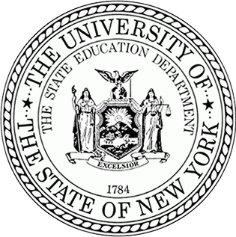
Facebook Twitter LinkedIn Email Share

January 2022 Regents Examinations Cancelled Due to Ongoing Pandemic
The January 2022 administration of the High School Regents Examination Program is cancelled due to the ongoing COVID–19 pandemic, State Education Commissioner Betty A. Rosa announced today. This cancellation applies to all Regents Examinations that had been scheduled for the January 2022 Regents Examination period. No decisions have been made regarding the June and August 2022 administrations of Regents Examinations or any other State assessment programs.
“Educators, school staff, communities, and families have taken painstaking efforts to ensure a safe and healthy school year," Board of Regents Chancellor Lester W. Young, Jr. said. "Given the unpredictable nature of the pandemic, the recent acceleration in COVID-19 infections, and continuing upheaval the virus has caused in schools across the state, this decision is the right one. New York's students will continue to have access to high-quality coursework while allowing districts to prioritize the health and safety of our school communities."
"New York set a daunting record last week with more COVID-19 cases reported in one day than ever before," Commissioner Rosa said. "Once again, the January Regents Exams cannot be safely, equitably, and fairly administered across the state. We will continue to work with our schools, districts, and stakeholders to ensure they have what they need to provide academic, social and emotional, and mental health supports for our students."

Modifications to Diploma Requirements for Students Impacted by the Cancellation of January 2022 Regents Examinations
Due to the cancellation of the January 2022 Regents Examinations, the Department will ask the Board of Regents to approve modifications to the assessment requirements that students must meet to earn high school diplomas, credentials, and endorsements. These modifications apply to all students who are completing a secondary-level course of study or make-up program in January and are scheduled to participate in one or more of the January 2022 Regents Examinations.

Regents Examination Exemptions
To ensure students are not adversely impacted by the cancellation of the exams, the Department will ask the Board of Regents to adopt emergency regulations regarding the assessment requirements students must ordinarily meet to earn a diploma. Under the proposed emergency regulations, students who are planning to take one or more Regents Examinations during the January 2022 examination period at the conclusion of a course of study or make-up program shall be exempt from the requirements pertaining to passing a corresponding Regents Examination to be issued a diploma. To qualify for the exemption, the student must meet one of these requirements by the end of the first semester of the 2021-22 school year:
- Be enrolled in a course that would ordinarily culminate with a January 2022 Regents Examination and earn credit for such course of study;
- Complete a make-up program to earn course credit; or
- Be prepared to take a required Regents Examination to graduate at the end of the first semester.
NYSED is developing additional guidance in the form of an FAQ and will issue that guidance in early January 2022 to address topics such as safety net options, mastery, honors, and technical endorsements so that schools may determine which diplomas to grant to their graduates. Please visit the Department’s COVID-19 Information site for additional information and guidance as it becomes available.

